# Brainstorm

###### Before you collaborate

A little bit of preparation goes a long way with this session. Here’s what you need to do to get going.

10 minutes

**1**

###### Define your problem statement

What problem are you trying to solve? Frame your problem as a How Might We statement. This will be the focus of your brainstorm.

5 minutes

**2**

###### Brainstorm

Write down any ideas that come to mind that address your problem statement.

10 minutes

**3**

###### Group ideas

Take turns sharing your ideas while clustering similar or related notes as you go. In the last 10 minutes, give each cluster a sentence-like label. If a cluster is bigger than six sticky notes, try and see if you and break it up into smaller sub-groups.

20 minutes

**4**

###### Prioritize

Your team should all be on the same page about what's important moving forward. Place your ideas on this grid to determine which ideas are important and which are feasible.

20 minutes

###### After you collaborate

You can export the mural as an image or pdf to share with members of your company who might find it helpful.

# & idea prioritization

SmartFarmer - IoT Enabled Smart Farming Application

1. **Team gathering**

Define who should participate in the session and send an invite. Share relevant information or pre-work ahead.

1. **Set the goal**

Think about the problem you'll be focusing on solving in the brainstorming session.

1. **Learn how to use the facilitation tools**

Use the Facilitation Superpowers to run a happy and

**PROBLEM**

**How might we [your problem statement]?**

##### **Thilagavathi**

Smart Weather Monitering Using IOT.

###### **swarnalakshmi**

IOT Based Three Phase Motor Starter controller

Smart Weather Monitering Using IOT.

Smart Weather Monitering Using IOT.

Mobile Notification

ultrasonic Detector

###### Quick add-ons

* 1. **Share the mural**

**Share a view link** to the mural with stakeholders to keep them in the loop about the outcomes of the session.

* 1. **Export the mural**

Export a copy of the mural as a PNG or PDF to attach to emails, include in slides, or save in your drive.

**10 minutes** to prepare

**1 hour** to collaborate

###### 2-8 people

recommended

Santhosh R Ananthan V

productive session.

**[Open article](https://support.mural.co/en/articles/2113740-facilitation-superpowers)**

###### Key rules of brainstorming

To run an smooth and productive session

#### Temprature &

Humidity

#### Rain Moniterining

water Management

#### Three Phase Voltage Decteing

Dry run Preventer

Water Overflow Moniter

### IOT Based Three Phase Motor Starter

Temprature &

Humidity

Automatic Animal Alerting System With Current Defense

###### Keep moving forward

**Strategy blueprint**

Define the components of a new idea or strategy.

**[Open the template](https://app.mural.co/template/e95f612a-f72a-4772-bc48-545aaa04e0c9/984865a6-0a96-4472-a48d-47639307b3ca)**

**Customer experience journey map**

Gopinath G

HarunRaghavan V

Stay in topic.

Defer judgment.

Encourage wild ideas.

Listen to others.

##### sarojini

**lakshmi**

### controller

###### Importance

If each of these

Rain

Moniterining

System.

Understand customer needs, motivations, and

obstacles for an experience.

**[Open the template](https://app.mural.co/template/b7114010-3a67-4d63-a51d-6f2cedc9633f/c1b465ab-57af-4624-8faf-ebb312edc0eb)**

Go for volume. If possible, be visual.

IOT Based Green House.

Automatic Animal Alerting System With Current Defense System.

## IOT Based Green House.

tasks could get done without any difficulty or cost, which would have the most positive impact?

### IOT Based Three Phase Motor Starter controller

Dry run Preventer

Temperature Controlling

## IOT Based Green

**Strengths, weaknesses, opportunities & threats**

Identify strengths, weaknesses, opportunities, and threats (SWOT) to develop a plan.

**[Open the template](https://app.mural.co/template/6a062671-89ee-4b76-9409-2603d8b098be/ca270343-1d54-4952-9d8c-fbc303ffd0f2)**

**[Share template feedback](https://muralco.typeform.com/to/CiqaHVat?typeform-source=app.mural.co)**

**[Share template feedback](https://muralco.typeform.com/to/CiqaHVat?typeform-source=app.mural.co)**

Weather Monitoring

#### Temperature Controlling

Live Monitoring

ultrasonic Detector

Mobile Notification

Alert Alarming

Automatic Animal Alerting System With Current Defense System.

Three Phase Voltage Decteing

###### Feasibility

Weather Monitoring

## House.

Regardless of their importance, which tasks are more feasible than others? (Cost, time, effort, complexity, etc.)

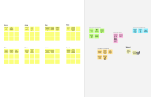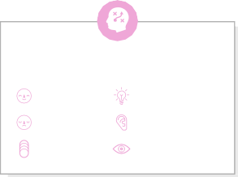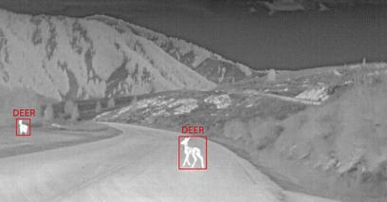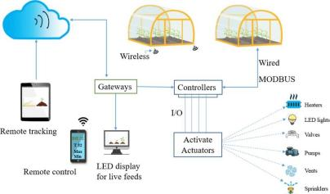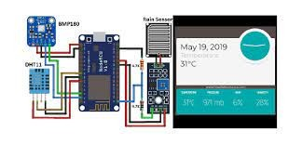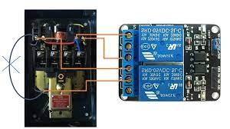

**Template**

**Need some inspiration?**

See a finished version of this template to kickstart your work.

**[Open example](https://app.mural.co/template/e5a93b7b-49f2-48c9-afd7-a635d860eba6/93f1b98d-b2d2-4695-8e85-7e9c0d2fd9b9)**